**Calculator.1.0**

**How to use Calc**

1. **Open/Jump to Calc**
2. **At the main menu choose Calc.**
3. **Press + when you are at any menu or a button list to jump to Calc.**
4. **Use Math Functions**
   1. 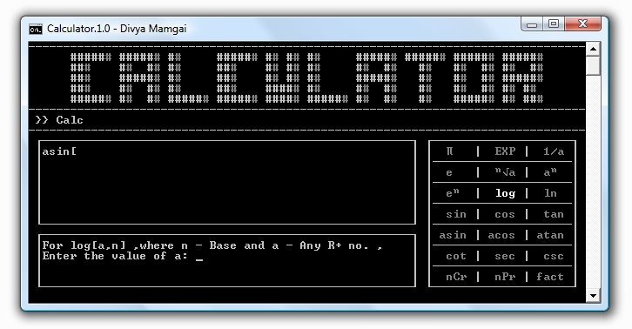**Press Insert when you are inputting the numbers in the input field.**
   2. **Pressing Insert again on the Math Function menu will take you back to inputting data or even pressing Escape will do the same.**
   3. **Or else you can just enter the right command for Math Function using keyboard in input field.**
5. **How choose different Math Functions**
   1. 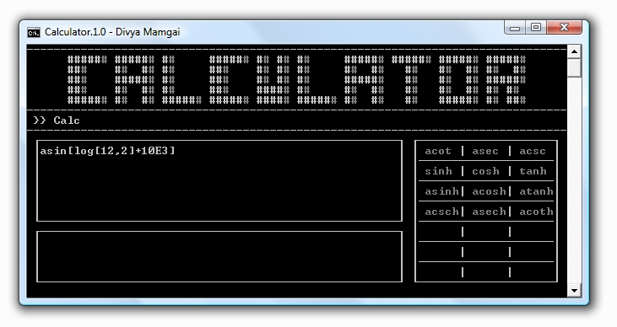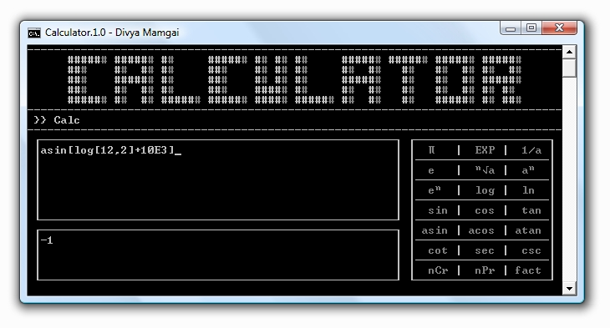**When you are inputting data in the input field press Page Up to scroll up a menu of Math Functions or press Page Down to scroll down a menu of Math Functions.**
6. **Why does program keep showing error that Calc won’t function?**

**This error occurs due to the fact that the program is not allowed to perform read or write functions dynamically, even if you run it as an administrator the program will still give false error. To solve this kindly install the program in a directory or drive this is not protected by administrator. This will not comprise with your system security.**